LANDSCAPE LIGHTING GUIDELINES

- All exterior lighting should be respectful of neighbors so lighting does not shine in neighboring windows or light areas beyond your lot.

- The light source, ie. light bulb, should not be visible from street, golf course, or adjoining
properties. (Decorative lighting for special occasions only i.e. wedding reception, birthday party, may be requested for that event to NPOA & Christmas lighting is allowed the weekend following Thanksgiving until day following New Year’s Day).

- Intensity of lighting should be ‘soft’ and subtle, not spotlighting. This is both for tree and shrub lighting and lighting of house facades.

- Lighting of designated and tagged woodpecker trees is prohibited. No lighting shall be placed on tagged trees, and irrespective of distance of light source, there shall no lighting, whatsoever, either directly or indirectly onto a designated tree.

SAMPLE OF ACCEPTABLE LIGHTING

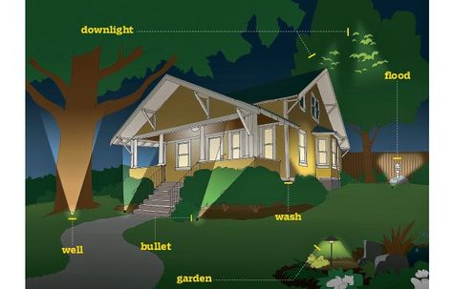

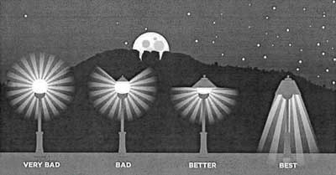
SAMPLE OF BAD TO GOOD LIGHTING

EXAMPLE B

